## Bash Shell Script

**Example: 1**

**Reading from the shell**

#/bin/sh

echo "First Name?"

read Firstname

echo "Surname?"

read Surname

echo "Age?"

read age

echo "Hello $Firstname $Surname, you are $age years old"

**Output:**

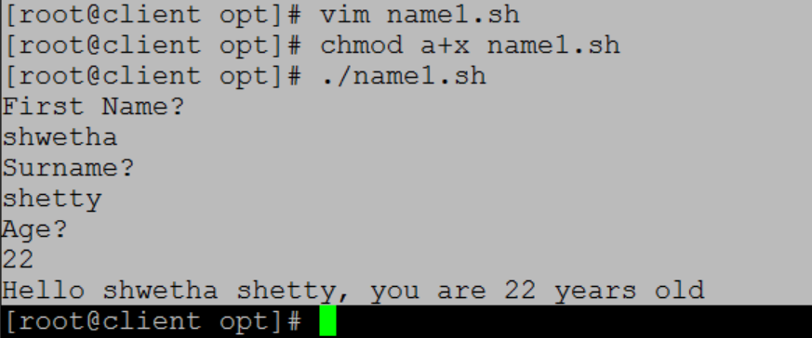

**Example: 2**

**Bash if/else statement**

#!/bin/bash

directory="./BashScripting" #/opt/BashScripting/---exixts

if [ -d $directory ]; then

echo "Directory exists"

else

echo "Directory does not exists"

fi

**Output:**

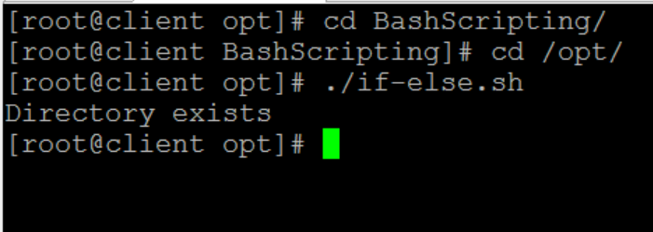

**Example: 3**

**Nested if/else**

## #!/bin/bash

## # Declare variable choice and assign value 4

## choice=4

## echo "1. Bash"

## echo "2. Scripting"

## echo "3. Task"

## echo -n "Please choose a word [1,2 or 3]? "

## while [ $choice -eq 4 ]; do

## read choice

## if [ $choice -eq 1 ] ; then

## echo "You have chosen word: Bash"

## else

## if [ $choice -eq 2 ] ; then

## echo "You have chosen word: Scripting"

## else

## if [ $choice -eq 3 ] ; then

## echo "You have chosen word: Task"

## else

## echo "Please make a choice between 1-3 !"

## echo "1. Bash"

## echo "2. Scripting"

## echo "3. Task"

## echo -n "Please choose a word [1,2 or 3]? "

## choice=4

## fi

## fi

## fi

## done

**Output:**

## 

If the choice is not between 1-3 then output is:

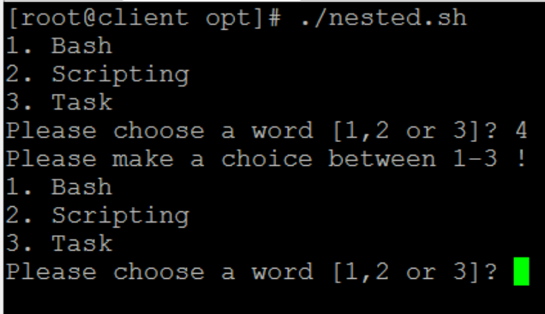

**Example: 4**

## Double Quotes

## #!/bin/bash

## #Declare bash string variable

## BASH_VAR="Bash Script"

## echo $BASH_VAR

## # meta characters and its special meaning in bash is

## # suppressed when using double quotes except "$", "\" and "`"

## echo "It's $BASH_VAR and \"$BASH_VAR\" using backticks: `date`"

**Output:**

## 

**Example: 5**

**Reading from the shell**

## #!/bin/bash

while :

do

clear

echo "-------------------------------------"

echo " Main Menu "

echo "-------------------------------------"

echo "[1] Show Todays date/time"

echo "[2] Show files in current directory"

echo "[3] Show calendar"

echo "[4] Start editor to write letters"

echo "[5] Exit/Stop"

echo "======================="

echo -n "Enter your menu choice [1-5]: "

read yourch

case $yourch in

1) echo "Today is `date` , press a key. . ." ; read ;;

2) echo "Files in `pwd`" ; ls -l ; echo "Press a key. . ." ; read ;;

3) cal ; echo "Press a key. . ." ; read ;;

4) vi ;;

5) exit 0 ;;

*) echo "Opps!!! Please select choice 1,2,3,4, or 5";

echo "Press a key. . ." ; read ;;

esac

done

**Output:**

**Choice: 1**

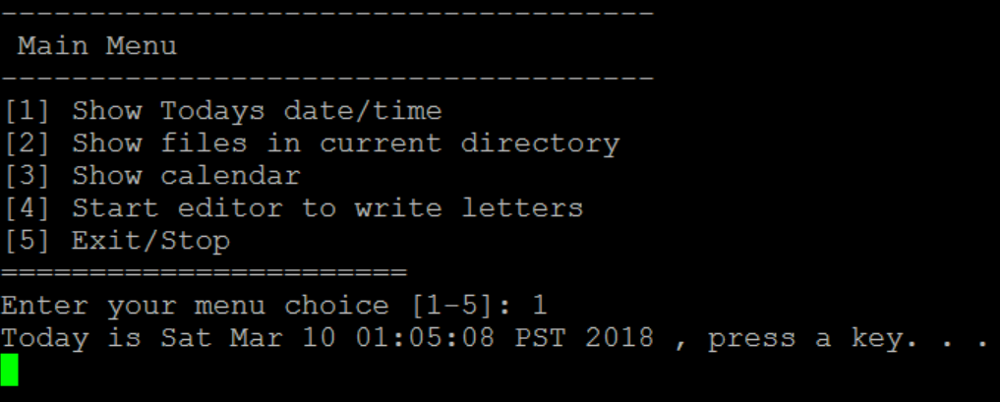

**Choice: 2**

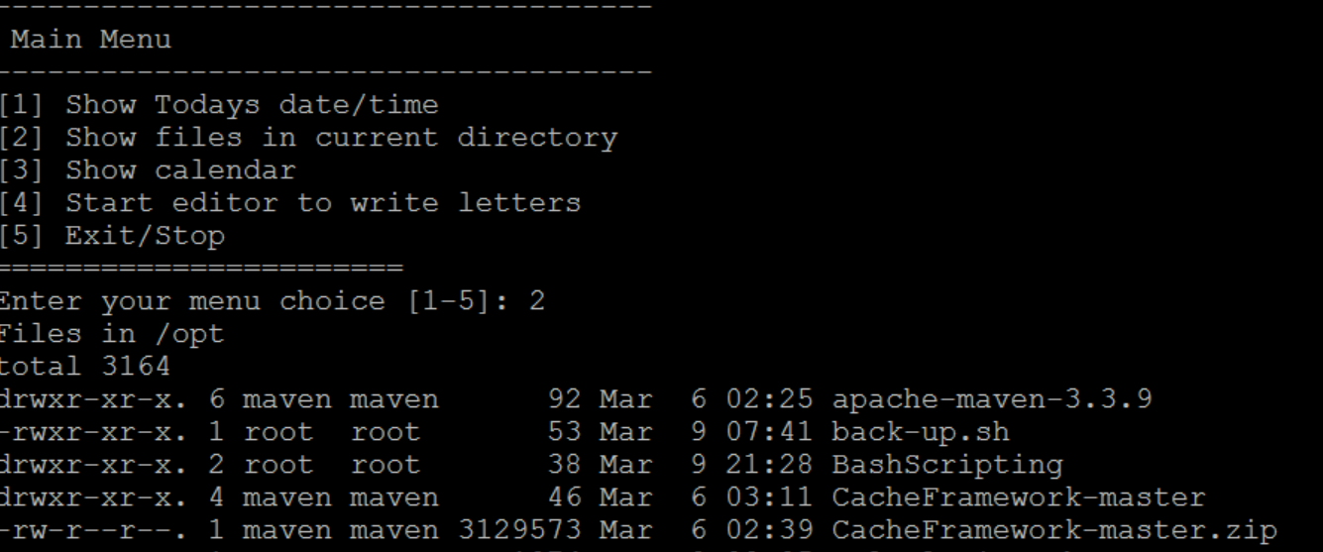

**Choice: 3**

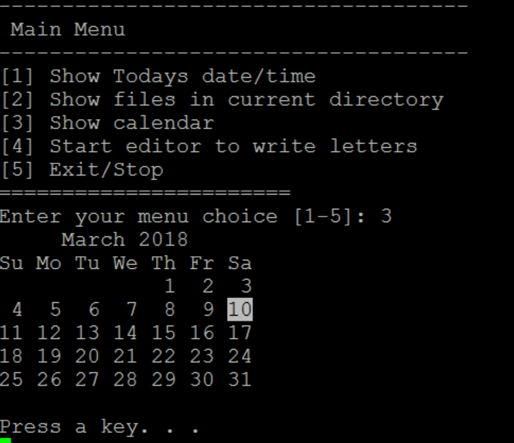

**Choice: 5**

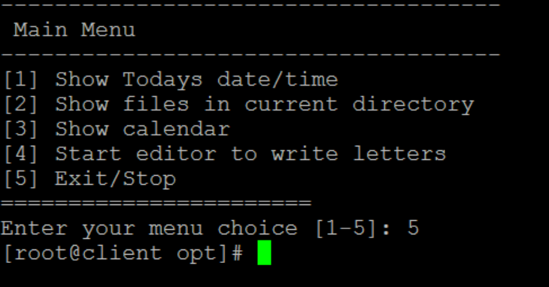

**Example: 6**

## Read file into bash array

## #!/bin/bash

## # Declare array

## declare -a ARRAY

## # Link filedescriptor 10 with stdin

## exec 10<&0

## # stdin replaced with a file supplied as a first argument

## exec < $1

## let count=0

## while read LINE; do

## ARRAY[$count]=$LINE

## ((count++))

## done

## echo Number of elements: ${#ARRAY[@]}

## # echo array's content

## echo ${ARRAY[@]}

## # restore stdin from filedescriptor 10

## # and close filedescriptor 10

## exec 0<&10 10<&-

**Output:**

## 